EE273 Engineering Design for

Software Development:

Neural Network Project

Andrii Kyrychok 2023182158

Ricardo Barrera 202315882

25/03/2025

Contents

1 Introduction 2

2 Project Description 2

2.1 Assumptions 2

3 Background theory 3

3.1 Neural Network Fundamental Concepts 3

3.2 Back Propagation 4

3.3 Convolutional Neural Networks 5

3.4 Layers in CNN 5

3.4.1 Convolution 6

3.4.2 Pooling 11

3.4.3 Deconvolution 11

3.4.4 Fully Connected 12

3.5 Activation functions 13

3.5.1 Sigmoid Function 14

3.5.2 Tanh Activation Function 14

3.5.3 ReLU (Rectified Linear Unit) 15

3.5.4 SoftMax Function 16

3.6 External Libraries 17

3.6.1 Eigen 17

3.6.2 OpenCV 18

3.6.3 Utilis 18

4 Program Desing and Implementation 18

4.1 Activation Functions 19

4.2 Base Layer 21

4.3 Convolution 21

4.4 Pooling 23

4.5 Deconvolution 25

4.6 Fully Connected 26

4.7 Neural Network 27

5 Testing and results 28

5.1 Activation Functions 28

5.2 Convolution Layer 29

5.3 Fully Connected 31

5.4 Deconvolution 32

5.5 Pooling 33

5.6 Neural Network 34

5.7 Image Processing 35

6 Future work and improvement 37

7 Conclusion 38

8 References 38

# Introduction

A Neural Network is a program structure, a structure that is key to an impressive number of modern computing applications [1]. It’s ability to learn from data sets alone allows it to be used in security, programming, language processing, conversational AI and any aspect of the world that needs data shaped to a graph. In this project, we aim to take a simple look at convolutional neural networks in attempt to better understand the underlying maths present in these neural networks, develop a program to build the components of these networks, as well as be able to build, test and connect the hidden layers present.

This will be achieved with C++, and certain external libraries, to efficiently implement matrix maths, use object-oriented language and build a program to demonstrate our research and our improvement in programming skills.

AI (GitHub Copilot) was exclusively used to help identify faults in code and made no original entries of its own.

# Project Description

A project description was provided, which stated the following:

***Build a library that represents some of the most common types of layers in a neural network (such as fully connected, pooling, convolution, deconvolution) and perform the necessary linear algebra. This system should allow you to chain together these layers, and check that the dimensions of a previous layers’ output is compatible with the next layers input*.**”

In developing the Project Description, the team created a set of User Requirements that captured the users' needs and expectations for the code. Establishing these requirements early in the process helped clarify the project's scope and limitations, guiding its implementation. The program is expected to include the following features:

1. Develop common types of neural network: fully connected, pooling, convolution, deconvolution
2. Implement activation functions
3. Functions to perform necessary linear algebra
4. Check that the dimensions are compatible with the next layer
5. Chain the layers developed
6. Inclusion of error handling
7. Perform all necessary steps to test the layer

## Assumptions

Taking a closer look at this project description, it seems apparent that the focus of this project is a Convolutional Neural Network (CNN), as it is a common neural network that contains the exact layers specified.

A key assumption made during development was that backpropagation would not be required for the final solution. This significantly reduced the overall workload, as it eliminated the need for gradient calculations and weight updates. By removing the complexities associated with training, more time and resources could be allocated to the core objectives of the project, allowing for improved focus and a more flexible project management timeline.

With that assumption the development of the Fully Connected Layer was simplified down to just multiplication of the given input to the weights of the layer.

# Background theory

## Neural Network Fundamental Concepts

A Neural Network at works on using known data, or training data, to teach a computer to fit a line to a set of data, allowing it to accurately predict the outcome of future input data. It achieves this using weights and biases to change the values of premade functions and summing those changes to build the optimal line for any data entry after training. Initially, these weights and biases are most likely poor at predicting the correct outcome of a test input, but using a process known as back propagation, it can use known training data to optimise these weights and biases to improve its predictions.

A great way to illustrate this is by using a simple Neural network, with the goal of identifying returning a safe dosage of medicine for treatment of a disease, this example is adapted from ‘The Essential Main Ideas of Neural Networks’[2].

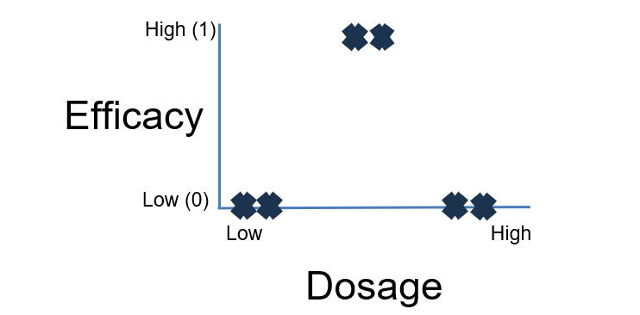As you can see in Figure 3.1, the best dosage for this medicine is a medium dosage between high and low dosage. We will use this to demonstrate a fully working neural network. A neural network fits a line to this curve using a few key features – nodes, and input layer, a hidden layer, an output layer, an activation function, weights, and biases. Its structure is arranged as shown below in figure 3.2.

Figure 3.1 Efficacy of test drug

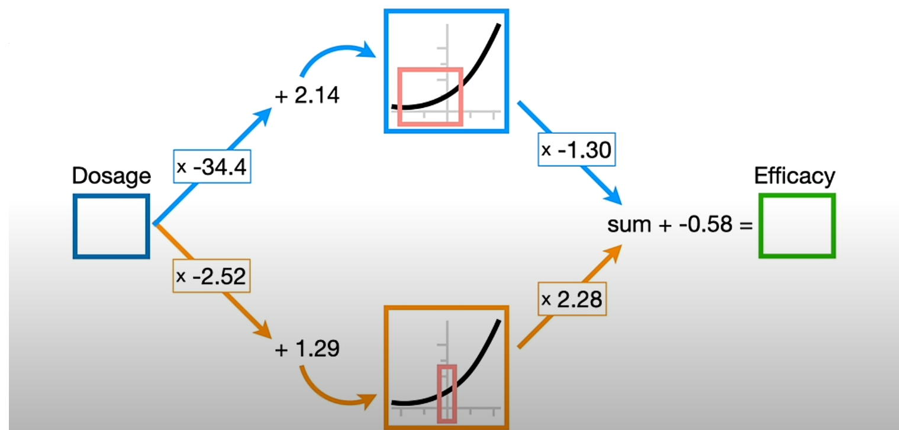

Figure 3. Screenshot of Completed Neural Network [2]

To begin, we must explain two simple and key concepts

1. A Neural Network layer is composed of Nodes
2. Nodes are a variable that stores a number, typically described alongside the maths applied to a number from a previous layer.

In this example, we see that the input layer is one node, that accepts a dosage value and sends it to one hidden layer of two nodes. In the process of moving a node from the input layer to a hidden layer, three important operations are performed. The end goal of using these hidden layers is to build a line graph that fits the training data. This function is achieved using an activation function – the most common of which are SoftMax (present above), ReLU, Sinusoidal and Tanh. This is because any graph can be constructed by adjusting and summing the value of these graphs. Additionally, Neural Networks are almost always designed to output a high/low output, such as a yes/no for whether a dosage is effective, meaning activation functions also limit the output of a neural network to between 1 and 0. In this case, the ranges of two SoftMax functions are adjusted using a weight and a bias. The blue branch multiplies the input by -34.4, a weigh, adds a bias of 2.14, finds the y value of the resultant number in the activation function, and finally multiplies this by -1.3, another weight, this creates a curve that tends towards zero from a negative value. In the orange path, this process is used to construct a function that begins very high and tends towards (but doesn’t reach) zero as the dosage increases. When these two constructed graphs are summed, we have successfully built a graph that fits the data, with the only sum that results in a high value being a middle dosage. This progression can be shown in Figure 3.3.

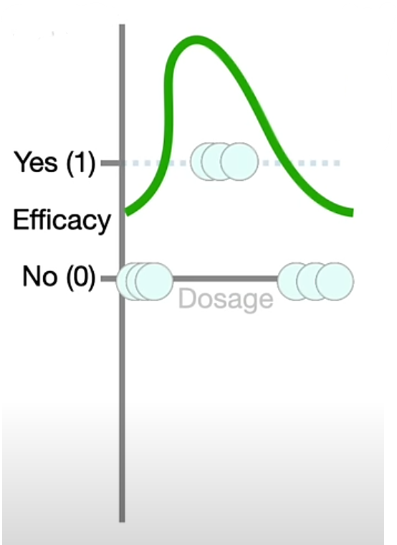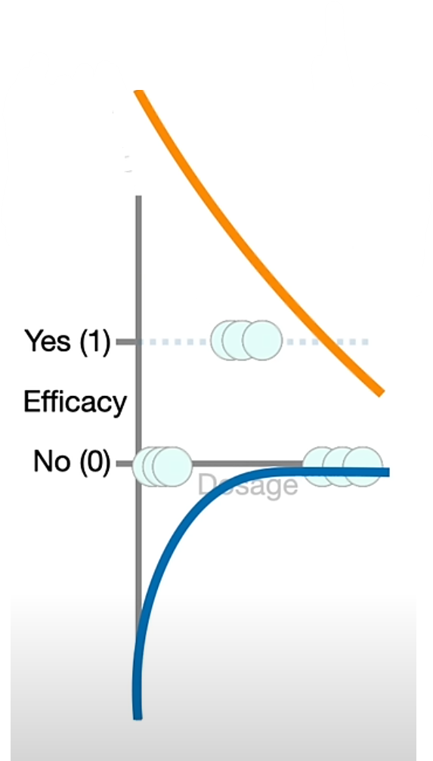

Figure .3 Screenshot of combination of neural network maths [2]

Finally, this constructed graph is moved using one final bias and sent to the output layer.

A Neural Network can be made with any number of input nodes, hidden layers and output nodes. On top of this, hidden layers can be connected to one another in various ways. Regardless, the goal of the neural network will always be to construct a graph that returns a high value that identifies an arbitrary output from an arbitrary input depending on what the user desires, all built on training data. By expanding the complexity of these neural networks, they can be adjusted to identify patterns in images, the best response to ‘translate this sentence to Spanish’ or to decide whether a user entering a website is human or not.

## Back Propagation

As described, back propagation is what allows neural networks to learn from training data. It functions by adjusting weights and biases to minimise error [3]. It does this by constructing a cost function. A cost function will analyse the output of a neural network operation and assign it a ‘cost’ depending on how incorrect the network is. A common value it derives in early neural networks is the mean squared error (MSE), which is the average of the squared errors or offsets between the network’s predicted results and the training data’s expected results.

$MSE$ = mean squared error

$ỹ_{i}$ = predicted values

$n$ = number of data points

$y_{i}$ = observed values

(1)

$$MSE= \frac{1}{n} \sum_{i=1}^{n}{{\left(y_{i}-ỹ_{i}\right)}^{2}}$$

The derivative of this error, with respect to the value of the weights and biases, is calculated. This is to allow the computer to target the lowest possible cost. If the gradient is negative, the weights and biases are increased or decreased to follow this negative trend. If we focus solely on weights, we can see this decision in action.

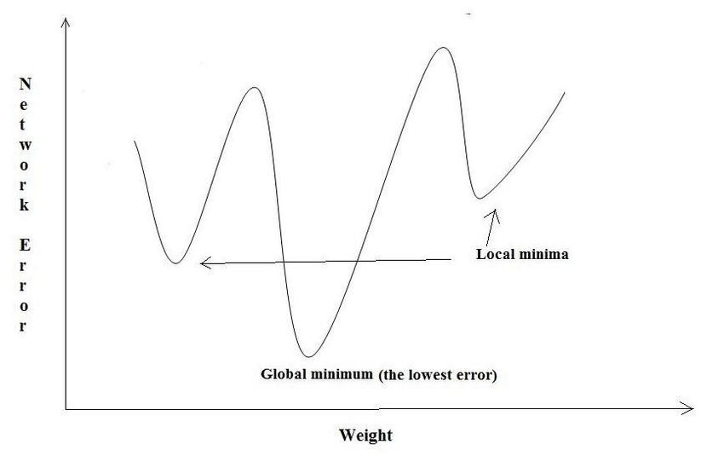Looking at Figure 3.4, we can see that if the error and weight of a connection is present on the black point, the negative tends towards the global minimum. In this instance, the maths supports the weight being reduced to minimise cost. Thus, the weight on this connection is reduced. This calculation is applied to every connection in a neural network. It is named back propagation as this process is first done between the output layer and the hidden layer connected to the output layer. The layer before this output layer will have applied its own weights and biases to affect the next layer. The cost of this layer must also be analysed, and weights adjusted so that the next layer can work of more accurately filtered data. This process is repeated until the first layer’s connections are reached. This achieves two important steps simultaneously. It improves the weights and biases of a layer to reach more confident conclusions for what it is filtering for. It also defines what a certain node in a hidden layer is looking for, as each node is building off other nodes to adjust its own activation function to best identify when it should be high, low, negative or positive to sum to the optimal line. An interesting property of back propagation is that it results in the neural networks creating their own search criteria between layers in the neural network, which are often ‘random’ to human users analysing them after a neural network has processed a lot of training data.

Figure 3. Back Propagation for weights [4]

An important property of back propagation is that it is not uncommon for the cost function to guide the weights and biases to a local minimum, as seen by the grey X in Figure 4. This is common, and generally is something that isn’t avoided. This is because in most instances the local minimum is ‘close’ to the global minimum, and thus the program can reach a state of minimal error without discovering the true global minimum, which would have to be achieved through luck.

## Convolutional Neural Networks

A convolutional neural network centres around applying our key operations in groupings or matrices [5]. This is done to allow layers of the neural networks to identify more complex patterns, such as lines in an image, by grouping weights and biases together in one matrix, which is then used to scan an entire data set that is also arranged in a matrix. The most common use for a neural network is to analyse image inputs, as these are readily converted into matrices.

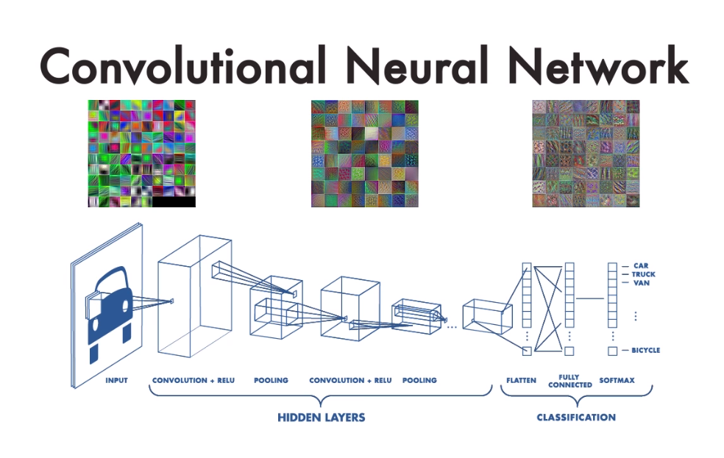This is because any image on a computer can be split into its use of red, green and blue colours at various intensities. Typically, an image input into a neural network will be divided into these essential colours and analysed by the CNN for distinguishable objects. As you can see in Figure 3.5, this CNN has been adjusted to identify various vehicles present in images. Looking at the grids on top reveals that the filters present in CNN can look very strange when illustrated. This is due to back propagation applied in CNN. Like other Neural Networks, the program won’t back propagate to generate ideas such as ‘wheel’ or ‘material’, and instead use arbitrary patterns sourced from the training data to identify the vehicles in these images, which when illustrated, look random to humans.

Figure 3.5 Convolution Neural Network Example [6]

The strength of CNN lies in the type of layers present in the network, which allows it to downscale or ‘convolute’ images to make their processing easier while searching for patterns, ‘Pool’ results to return positives in a smaller layer, deconvolute the image to return a correctly sized layer of positives and negatives of the various patterns that were searched for, and fully connect these positives and negatives into results of the analysis. These layers will be the primary focus of the program developed.

## Layers in CNN

Convolutional Neural Networks (CNNs) are composed of several specialized layers, each designed to handle different aspects of data processing. These layers work together to automatically extract features from input data and make predictions based on those features. The combination of these layers allows CNNs to learn complex patterns and representations, particularly from image or spatial data.

Among the core types of layers in CNNs are convolutional, pooling, deconvolutional, and fully connected layers. Each serves a distinct role within the network architecture. Convolutional and pooling layers are primarily used for feature extraction and dimensionality reduction, while deconvolutional and fully connected layers are typically responsible for reconstructing data or making final predictions based on the extracted features.

The layered structure of CNNs enables a hierarchical learning process, where early layers capture simple patterns and deeper layers learn increasingly abstract representations. This makes CNNs highly effective for a wide range of tasks such as image classification, object detection, and segmentation, with each layer contributing to the overall learning and inference process.

### Convolution

Affine transformations form the foundational operation in neural networks. These involve receiving an input vector, multiplying it by a weight matrix, adding a bias vector, and then typically applying a non-linear activation function. This transformation process can be applied to any input type — whether an image, audio signal, or a collection of features—since all such data can be flattened into vectors.

However, many types of data, such as images and audio, inherently possess structural properties that are not exploited when using standard affine transformations. Specifically, they are often represented as multi-dimensional arrays and have the following characteristics:

* **Dimensional structure:** Data is stored in arrays with one or more axes where ordering is important (e.g., spatial dimensions in images, temporal dimension in audio).
* **Channel axis:** A dedicated axis is used to differentiate between various views of the data (e.g., RGB channels in images or stereo channels in audio).

Affine transformations ignore this structure by treating all axes uniformly, potentially losing valuable spatial or temporal information. Preserving this inherent structure is crucial in tasks such as computer vision and speech recognition.

This is where discrete convolutions become essential. Convolutional operations are linear transformations that maintain spatial or temporal ordering. They are also:

* **Sparse:** Only a limited number of input units contribute to a given output unit.
* **Parameter-efficient:** The same kernel (set of weights) is applied across different input regions, enabling parameter sharing.

A typical convolution operation involves sliding a kernel (a small matrix of weights) across the input feature map (see Figure 3.1). At each position, the element-wise product of the kernel and the overlapping input region is computed and summed to generate a single output value. This process is repeated over the entire input, and multiple kernels can be used to produce multiple output feature maps (see Figure 3.3).

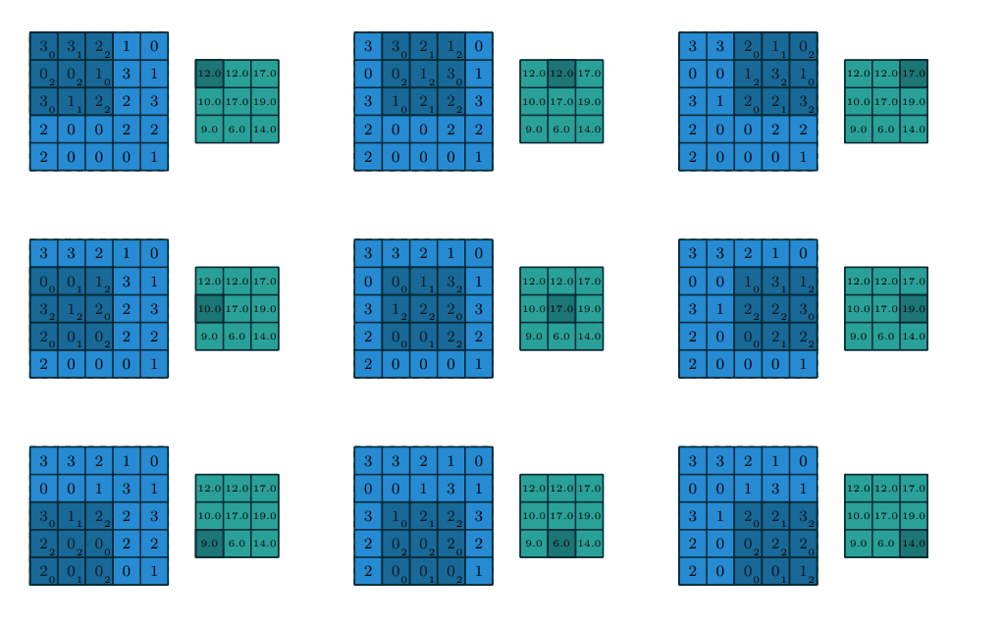

Figure .. Computing the output values of a discrete convolution [7]

When multiple input feature maps exist (e.g., multiple channels), the convolutional kernel must accommodate this by being three-dimensional. Each input feature map is convolved with a corresponding slice of the kernel, and the results are summed element-wise to yield the final output feature map. Although the example discussed primarily refers to 2D convolutions (common in image processing), the concept generalizes to N-dimensional convolutions. For instance, in 3D convolutions used in volumetric data, kernels are cuboid in shape and slide over three axes — height, width, and depth.

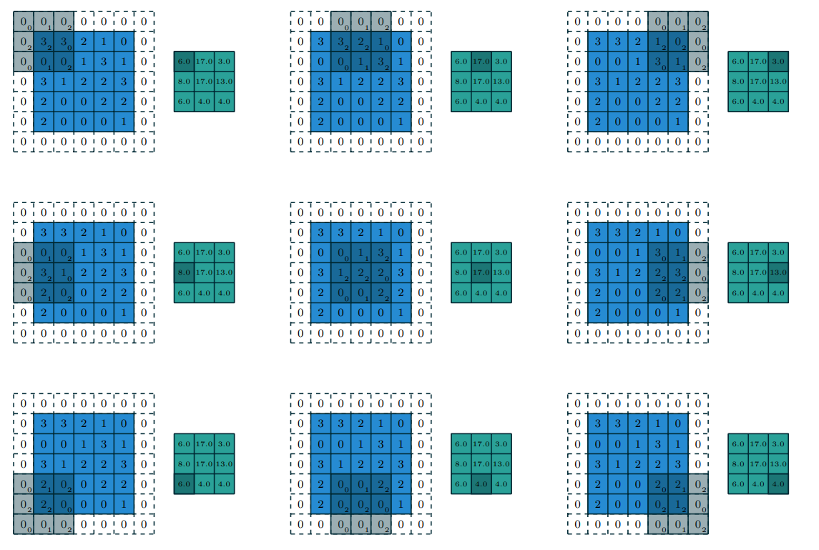

Figure .. Computing the output values of a discrete convolution for padding = 0 and stride = 2 [7]

The shape of a convolutional kernel is typically denoted by a permutation of the tuple (*n, m , k1,..., kN*), where:

* *n* = number of output feature maps,
* *m* = number of input feature maps,
* *kj* ​ = kernel size along axis *j*.

Several factors influence the output size *oj*​ of a convolutional layer along each axis *j*, including:

* *ij​*: input size along axis *j*,
* *kj* ​: kernel size along axis *j*,
* *sj*​: stride, or the step size of the kernel,
* *pj*: zero padding, specifying the number of zero elements added to each end of the axis.

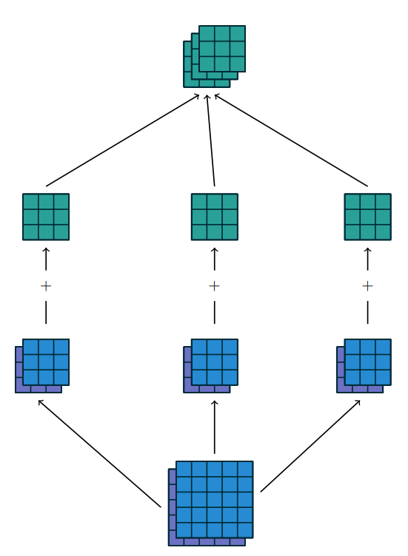

Figure .. Multiple output feature maps after convolution operation [7]

For example, applying a 3×3 kernel to a 5×5 input with 1×1 zero padding and a stride of 2 results in a reduced output due to both the padding and the stride (see Figure 3.2). Notably, strides act as a subsampling mechanism. Conceptually, a stride of 2 can be viewed as taking the kernel output at every alternate location, effectively reducing resolution. This can also be interpreted as moving the kernel by a stride of 1 while retaining only the outputs at every second position (see Figure 3.4). There are many different cases of convolutions (see Figures 3.5 – 3.9) and the output size can be described by the formulas, but the most general and the one being used for implementation is

$o=\left[\frac{i+2p-k}{s}\right]+1$

(2)

Where o – output size of the matrix, i – input matrix size, k – size of the filter (kernel) matrix, p – padding and s – stride.

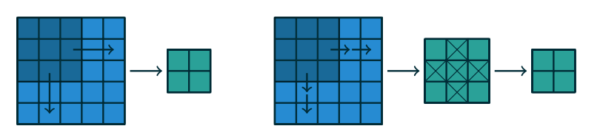

Figure .. An alternative way of viewing strides. Instead of translating the 3 × 3 kernel by increments of s = 2 (left), the kernel is translated by increments of 1 and only one in s = 2 output elements is retained (right). [13]

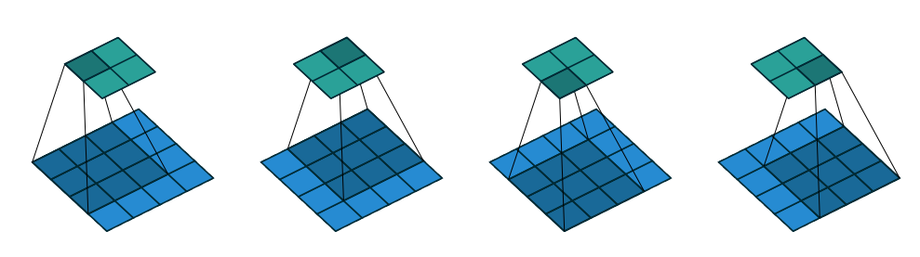

Figure .: (No padding, unit strides) Convolving a 3 × 3 kernel over a 4 × 4 input using unit strides (i.e., i = 4, k = 3, s = 1 and p = 0). [7]

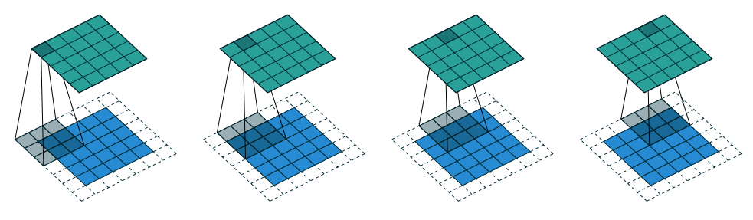

Figure .: (Half padding, unit strides) Convolving a 3 × 3 kernel over a 5 × 5 input using half padding and unit strides (i.e., i = 5, k = 3, s = 1 and p = 1). [7]

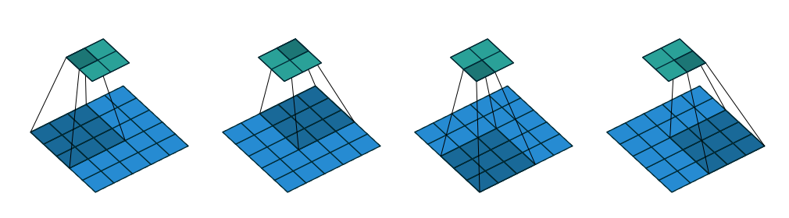

Figure .: (No zero padding, arbitrary strides) Convolving a 3 × 3 kernel over a 5 × 5 input using 2 × 2 strides (i.e., i = 5, k = 3, s = 2 and p = 0). [7]

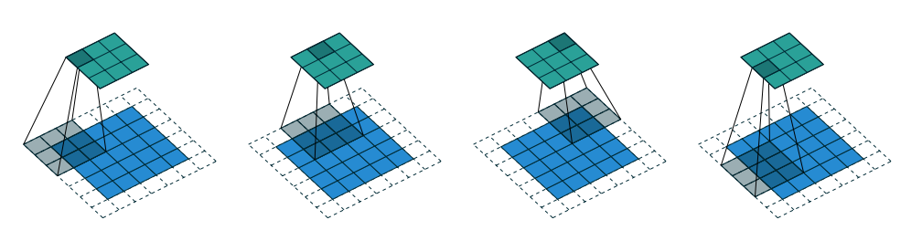

Figure .: (Arbitrary padding and strides) Convolving a 3 × 3 kernel over a 5 × 5 input padded with a 1 × 1 border of zeros using 2 × 2 strides (i.e., i = 5, k = 3, s = 2 and p = 1). [7]

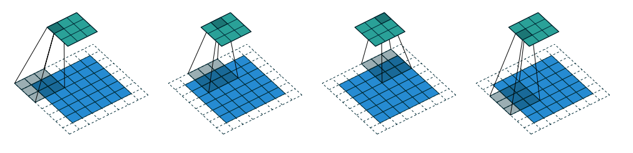

Figure .: (Arbitrary padding and strides) Convolving a 3 × 3 kernel over a 6 × 6 input padded with a 1 × 1 border of zeros using 2 × 2 strides (i.e., i = 6, k = 3, s = 2 and p = 1). In this case, the bottom row and right column of the zero padded input are not covered by the kernel. [7]

### Pooling

These layers are often used in series with convolution layers to make the dimensions of the input matrices or maps from the convolution layer smaller while retaining the most relevant information from the pooling. There are multiple reasons this layer is used alongside convolutional neural networks.

-The central use of pooling layers is to reduce the number of computations, and thus parameters the computer must process, allowing the program to run more efficiently.

-It also makes the entire structure more resistant to slight changes in images, as an area will still give the same output if slightly different.

- A biproduct of generalising data like a pooling layer does is preventing overfitting, which occurs when a neural network cannot generalise one of its filters

-Pooling layers can create a hierarchy of layers, distinguished by how general their search criteria are. Early pooling layers will still pick up on finer details, while later pooling layers will capture more general features of a picture analysis. This makes the neural network easier to analyse by computer scientists and engineers

A pooling layer operates by either searching for the maximum value in a certain window of the input layer or averaging all the values present in its search window. This value is entered into the pooling layer’s matrix, and a stride is taken to analyse a new area of the input layer. This means pooling layers often don’t include the use of activation functions or weights and biases, as their job isn’t to filter the data for patterns, but rather to summarize the previous layer’s analysis.

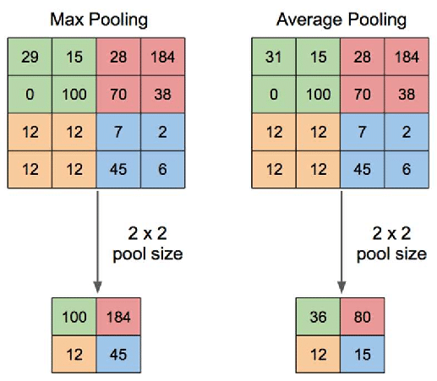The operation of a pooling layer in both regards can be seen in Figure 3.15 below.

Figure 3. Pooling Layers

Since the pooling layer isn’t subject to back propagation, they are instead optimised by their window size and stride, both of which control how much detail the pooling layer will remove. In some instances, padding is included in the input layer to allow the pooling layer to retain priority over features near the edge of the input layer.

### Deconvolution

Deconvolution is one of the final steps in the application of a convolutional neural network. It’s purpose is to resize the input layer into a layer of equal size to the original input map. After the series of convolutional and pooling layers, the remaining layer is much smaller than the original images. This is undesirable as CNN often returns the analysis of the image, such as searching for straight lines, as an altered version of the original image, displaying the results.

If applied and propagated correctly, a deconvolution layer can effectively increase the resolution of any input map. This makes it unique, as it isn’t only used as a final step for any CNN, but also as an image upscaling tool. This gives it purpose in scientific analysis, digital media and security applications as being able to artificially increase the amount of information that can be attained from an input image or matrix

The operation of a deconvolution layer is precisely the inverse of the convolution layer, using the same properties of padding, kernel(stride) and a window. The animation of this can be seen in Figures 16 and 17 below



Figure 3. Deconvolution animation stride 2 [7]

Figure 3. Deconvolution animation stride 1 [7]

In Figure 3.17, we can see the window of 3x3 being applied to an input layer of 2x2, with a padding of 2 layers and a stride of 1. The values inside the window are back propagated to ensure the upscaled values are optimized for their respective use.

### Fully Connected

A Fully Connected layer is a type of neural network layer where every neuron in the layer is connected to every neuron in the previous and subsequent layers. The "fully connected" descriptor comes from the fact that each of the neurons in these layers is connected to every activation in the previous layer (see Figure 3.13).

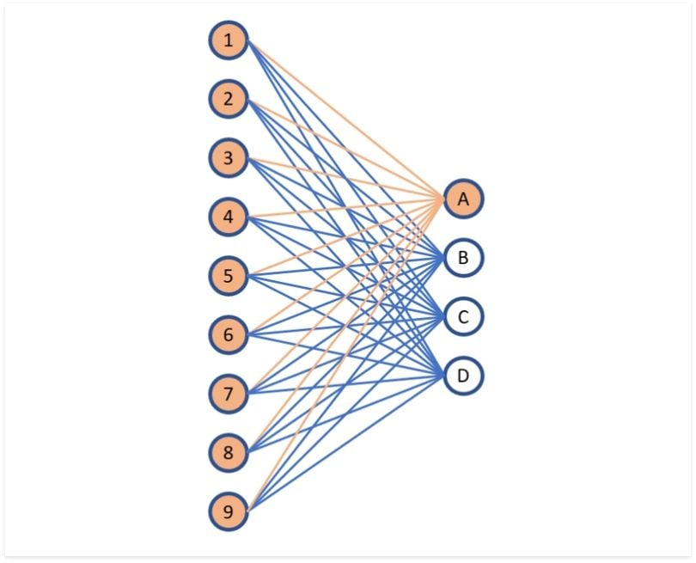

Figure .: Fully Connected Layer diagram   
[8]

* In CNNs, fully connected layers often follow convolutional and pooling layers, serving to interpret the feature maps generated by these layers into the final output categories or predictions.
* In fully connected feedforward networks, these layers are the main building blocks that directly process the input data into outputs.

The structure of FC layers is one of the most significant factors that define how it works in a neural network. This structure involves the fact that every neuron in one layer will interconnect with every neuron in the subsequent layer.

A Fully Connected layer is characterized by its dense interconnectivity. Here’s a breakdown of its key components:

* Neurons: Basic units that receive inputs from all neurons of the previous layer and send outputs to all neurons of the subsequent layer.
* Weights: Each connection between neurons has an associated weight, indicating the strength and influence of one neuron on another.
* Biases: A bias term for each neuron helps adjust the output along with the weighted sum of inputs.
* Activation Function: Functions like ReLU, Sigmoid, or Tanh introduce non-linearity to the model, enabling it to learn complex patterns and behaviours.

Since the project description does not expect a development of Forward Propagation the functionality of the layer is simplified down to multiplication of input matrix to the weight’s matrix without biases.

## Activation functions

Activation functions play a critical role in neural networks by introducing non-linearity into the model [9]. Applied to the output of each neuron, these functions enable the network to capture and learn complex patterns in data. Without non-linear activation functions, a neural network—regardless of its depth—would behave like a linear model and be unable to solve non-linearly separable problems.

The activation function determines whether a neuron should be activated by computing the weighted sum of its inputs, adding a bias term, and then applying the non-linear transformation. This mechanism allows the network to make more sophisticated decisions and predictions by enabling each neuron to contribute a non-linear output.

Non-linearity refers to a relationship between input and output that is not proportional. In other words, changes in input do not produce consistent, directly scaled changes in output. This property is essential for modelling complex real-world data.

For example, consider the task of classifying apples and bananas based on features such as shape and colour:

* A linear function could only separate them using a straight-line decision boundary.
* However, real-world data may be noisy or overlapping (e.g., similar colours under different lighting conditions).
* Non-linear activation functions such as ReLU, Sigmoid, or Tanh allow the model to form curved and flexible decision boundaries that better separate the classes.

By incorporating non-linearity, neural networks gain the capacity to:

* Model complex, non-linearly separable relationships,
* Learn multiple decision boundaries from combinations of weights and biases,
* Generalize better across varied datasets.

Each neuron in a neural network utilizes a combination of weights, biases, and an activation function. During training, the network adjusts these parameters through backpropagation, a process that relies on gradients to minimize the output error. Activation functions are essential to this process, as they provide the gradients needed for updating weights and biases.

Without activation functions, even deep neural architectures would be restricted to solving only basic, linear problems. By introducing non-linear transformations at each layer, activation functions empower neural networks to learn abstract representations, capture intricate data distributions, and solve a wide range of complex deep learning tasks.

### Sigmoid Function

**Sigmoid Activation Function** is characterized by ‘S’ shape. It is mathematically defined as

$A= \frac{1}{1+ e^{-x}}$

​​

(3)

This formula ensures a smooth and continuous output that is essential for gradient-based optimization methods.

* It allows neural networks to handle and model complex patterns that linear equations cannot.
* The output ranges between 0 and 1, hence useful for binary classification.
* The function exhibits a steep gradient when x values are between -2 and 2. This sensitivity means that small changes in input x can cause significant changes in output y, which is critical during the training process.

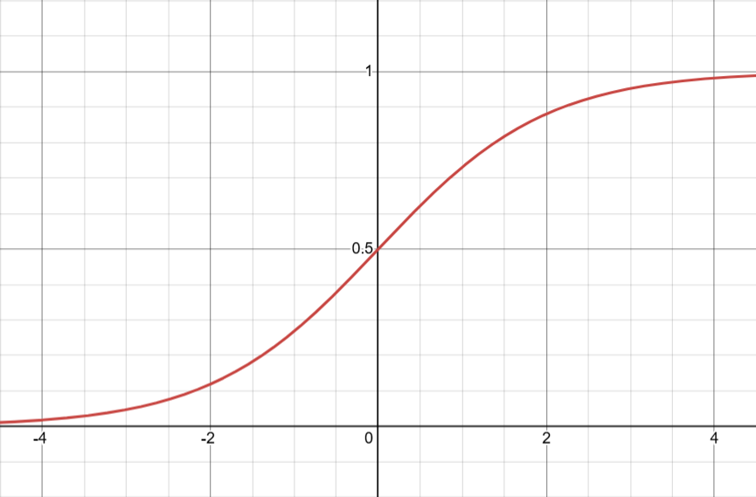

Figure .: Sigmoid Activation Function (Generated using Desmos Graphing calculator: https://www.desmos.com/calculator)

### Tanh Activation Function

**Tanh function (hyperbolic tangent function),** is a shifted version of the sigmoid, allowing it to stretch across the y-axis. It is defined as:

(4)

$$f\left(x\right)=\tanh\left(x\right)= \frac{2}{1+e^{-2x}}-1$$

* **Value Range**: Outputs values from -1 to +1.
* **Non-linear**: Enables modelling of complex data patterns.
* **Use in Hidden Layers**: Commonly used in hidden layers due to its zero-centred output, facilitating easier learning for subsequent layers.

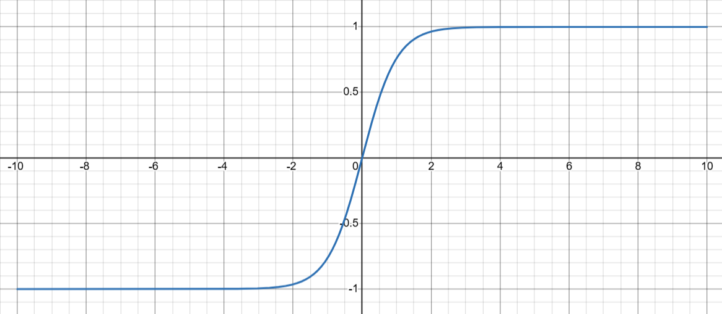

Figure .: Tanh Activation Function (Generated using Desmos Graphing calculator: https://www.desmos.com/calculator)

### ReLU (Rectified Linear Unit)

**ReLU activation** is defined by

(5)

$A\left(x\right)=max⁡(0, x)$

this means that if the input x is positive, ReLU returns x, if the input is negative, it returns 0.

* **Value Range**: [0, ∞), meaning the function only outputs non-negative values.
* **Nature**: It is a **non-linear** activation function, allowing neural networks to learn complex patterns and making backpropagation more efficient.
* **Advantage over other Activation:**ReLU is less computationally expensive than tanh and sigmoid because it involves simpler mathematical operations. At a time only a few neurons are activated making the network sparse making it efficient and easy for computation.

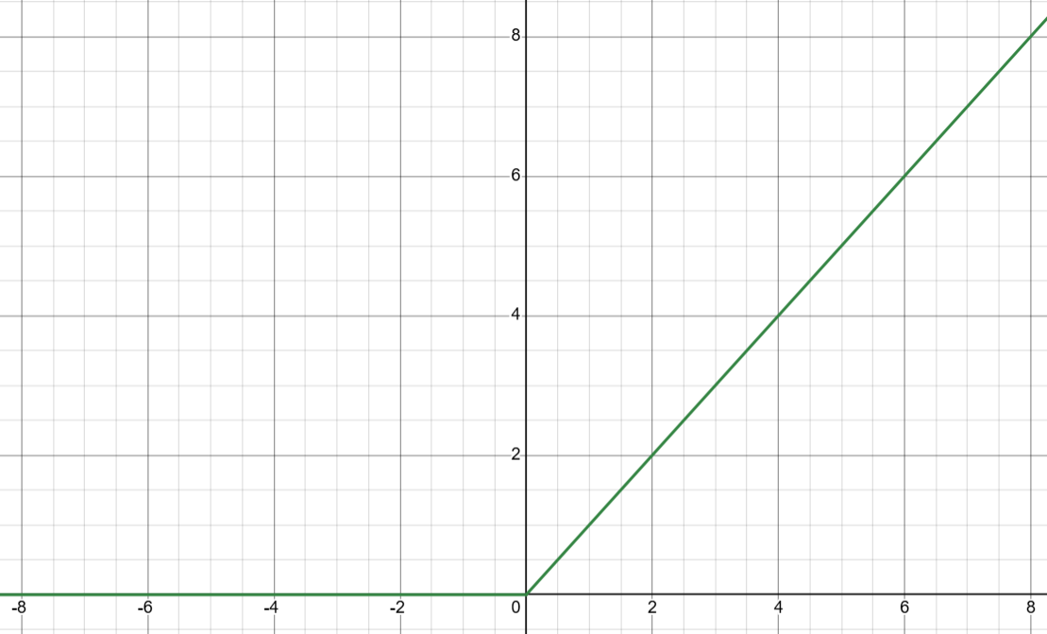

Figure .: ReLU Activation Function (Generated using Desmos Graphing calculator: https://www.desmos.com/calculator)

### SoftMax Function

The **SoftMax function** is a non-linear activation function specifically designed for **multi-class classification tasks**. Its primary purpose is to convert the raw output scores (also called logits) produced by the final layer of a neural network into a probability distribution over multiple class. Mathematically, the SoftMax function transforms a vector of real-valued scores into a vector of values in the range [0, 1], where each value represents the estimated probability of the input belonging to a particular class. Importantly, the output probabilities are normalized so that their sum equals 1, which makes them interpretable as categorical probabilities.

The SoftMax function is defined as:

(6)

$$Softmax\left(x_{i}\right)= \frac{e^{x_{i}}}{\sum_{j=1}^{n}{e^{x_{j}}}}$$

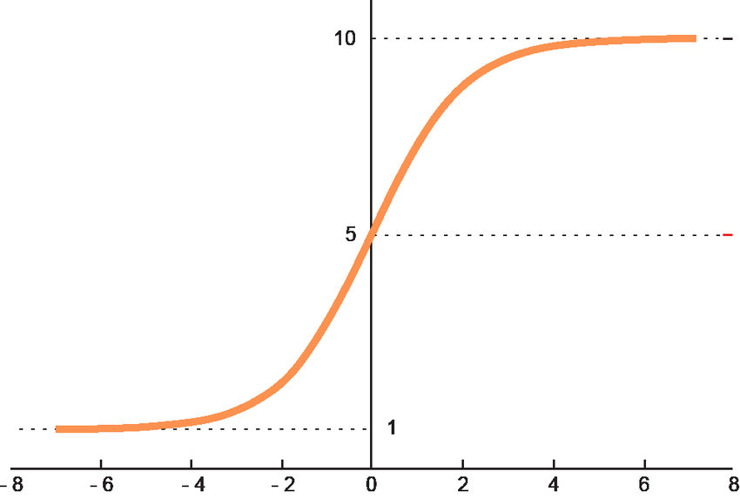

Figure .: Softmax Activation Function (https://www.researchgate.net/figure/Graphic-representation-of-the-softmax-activation-function_fig5_348703101)

## External Libraries

Throughout the project two open-source external libraries were used to focus on the main goal of developing basic layers and chaining them together. These libraries are “Eigen” and “OpenCV”

### Eigen

Eigen is a C++ template library [10] for linear algebra: matrices, vectors, numerical solvers, and related algorithms. Examples of addition, subtraction, scalar multiplication and division are given in the Code listings 3.1 and 3.2.

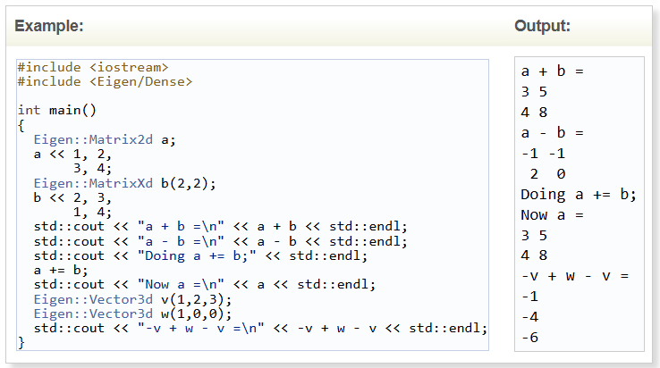

Code Listing .: Addition and subtraction of matrices (https://eigen.tuxfamily.org/dox/group__TutorialMatrixArithmetic.html)

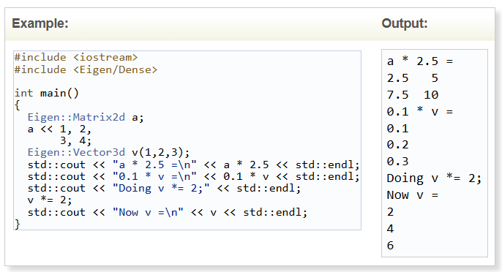

Code Listing .: Scalar multiplication and division of matrices (<https://eigen.tuxfamily.org/dox/group__TutorialMatrixArithmetic.html>)

The most useful application of Eigen for this project was the use of specialised variable types, as well as the predefined function for adding padding, finding maximum or minimum values and printing results.

### OpenCV

OpenCV (Open-Source Computer Vision Library: http://opencv.org) is an open-source library that includes several hundreds of computer vision algorithms. It was used for image processing such as converting an image into matrix and back from matrix into image (see Code Listing 3.3).

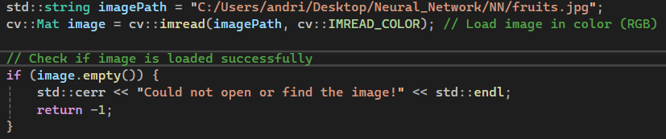

Code Listing .: Loading image into matrix

### Utilis

It is also worth noting that separate library utils was implemented to short the used of C++ standard library “cout” and “cerr” output streams. It has corresponding header and “.cpp” file filled with function print which is overloaded with different data types and “error()” function that uses “cerr” to print out the error message to the user in case of error occurring with description provided instead of crushing the terminal.

# Program Desing and Implementation

To develop the functionality of the layers and neural network a high-level UML diagram was created (see Figure 1). From the diagram neural network has a composition relationship with the base layer and all the rest are aggregated from base layer. This will then allow us to chain together because layer type be a child of the base layer parent class (inherited).

Neural Network

Base Layer

Convolution

Deconvolution

Pooling

Fully Connected

Eigen

Utils

OpenCV

Figure 4.: High level UML Diagram

## Activation Functions

Mentioned functions in section 3 were implemented as a separate library using header and functionality implementation named “ActivationFunction.h” and “ActivationFunction.cpp”. Then the library would be connected straight to the layers which will require them without user’s ability to access them.   
In the next part of the section the code listings for the header and functions will be displayed and explained.

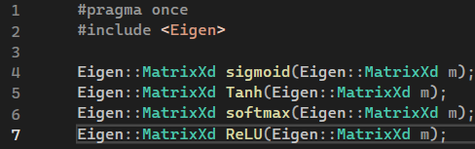

Code Listing .: Activation Functions Header File

It makes use of namespace Eigen which is the external library mentioned above and its class “MatrixXd” which represents a dynamically sized matrix of double precision elements. The functionality of each of the functions is represented in Code Listings 4.2 – 4.5.

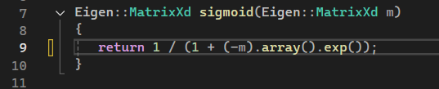

Code Listing .: Sigmoid Function Implementation

The parameter and a return of the function are of the matrix type explained above. It also has two functions for the matrix class “.array()” and “.exp()”. The first function turns the matrix into an array and second function applies exponent to each element of the function and after that the result is being automatically converted back into a matrix of the same size as it was at the parameter stage. To develop the piece of code the formula from Section 3.2.1 was used.

Second function in order of the header is Tanh which was very easy to implement because the Eigen library already provides a function “tanh.()” that does the operation described in Section 3.2.2 (see Code Listing 4.3).

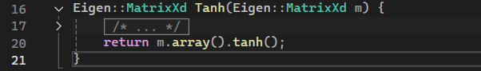

Code Listing .: Tanh Activation Function

ReLU was the third function to implement, and the implementation is shown in Code Listing 4.4.

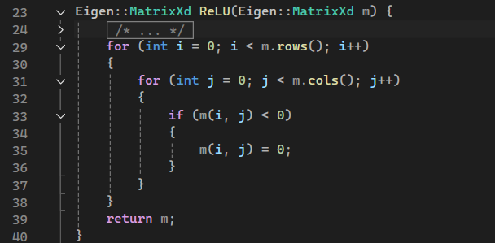

Code Listing .: ReLU Activation Function

The ReLU function loops through every column element in every row, and checks if the value is less than 0, and if it is, sets this value as zero. This allows it to remove all negative inputs into the function.

The SoftMax activation function can be found in Code Listing 4.5. First loop is used to calculate the denominator of the formula given in Section 3.2.4 which is total exponent. Second loop applies the function to every single element of the matrix.

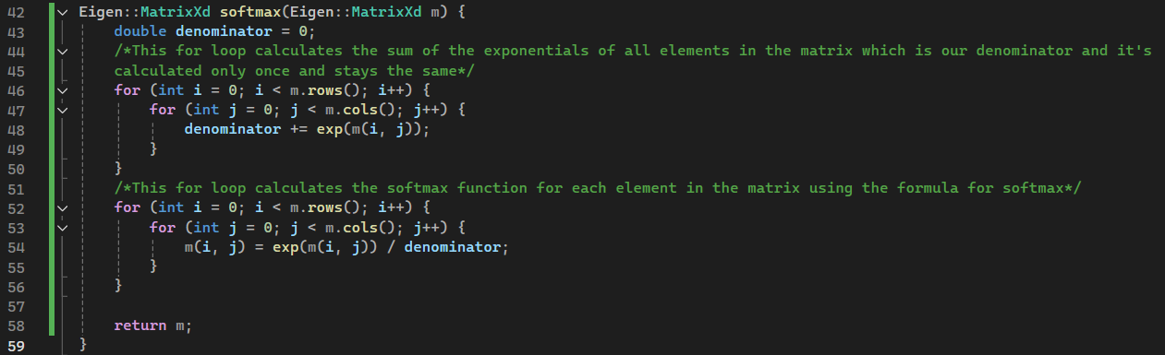

Code Listing .: SoftMax Activation Function

## Base Layer

Base Layer serves as a minimal and straightforward parent class for all derived layers in the neural network. It is defined only in a header file, as it does not provide any functional implementation and primarily exists to establish a common interface for its subclasses. In Code Listing 4.6 the code for the layer is provided.

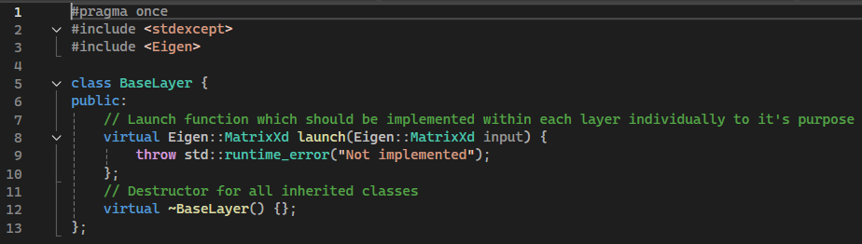

Code Listing .: Base Layer class in C++

The class is made up of two virtual components a custom function “launch” and destructor. The virtual type suggests that those attributes are going to be overwritten in the inherited classes which are layers in our case. An error is going to be thrown if the function is not overridden or called from the BaseLayer.

## Convolution

Convolution layers consist of a header and “.cpp” together with all of the subsequent layers. The list of attributes of the class is provided in Attributes 1 and the description can be found in Table 1.

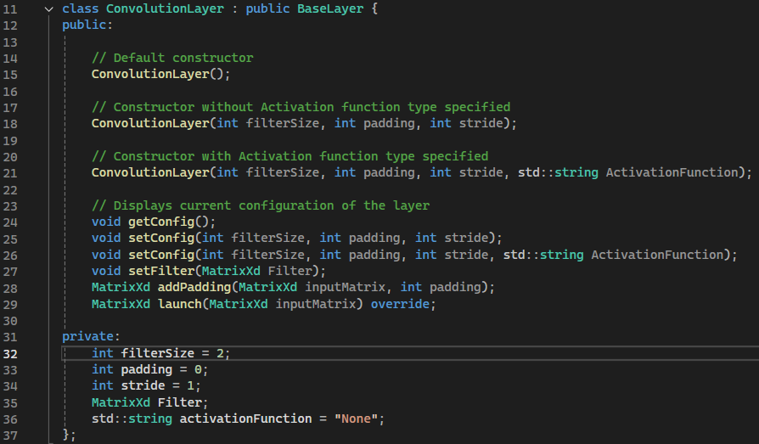

Attributes : Convolution Layer Class Attributes

|  |  |  |  |  |
| --- | --- | --- | --- | --- |
| **Name** | **Type** | **Return Type** | **Member Type** | **Purpose** |
| ConvolutionLayer (Parameters) | Constructor | Class object instance | Public | Creates an object with the properties of the class |
| getConfig() | Getter | Void | Public | Prints the specification of the layer |
| setConfig() | Setter | Void | Public | Changes the specification of the layer |
| setFilte()r | Setter | Void | Public | Changes the filter for the given layer |
| addPadding() | Function | MatrixXd | Public | Performs padding operation |
| launch() | Function | MatrixXd | Public | Main function that runs the layer |
| filterSize | Variable | Int | Private | Filter matrix size |
| padding | Variable | Int | Private | Padding size |
| stride | Variable | Int | Private | Stride size |
| Filter | Variable | MatrixXd | Private | Filter of the layer as a matrix |
| Activation Function | Variable | String | Private | Specified activation function |

Table : Class Attributes

The main “launch()” function is presented in Code Listing 4.7 excluding error handling. After the main body the switch case for activation comes in place (Code Listing 4.8).

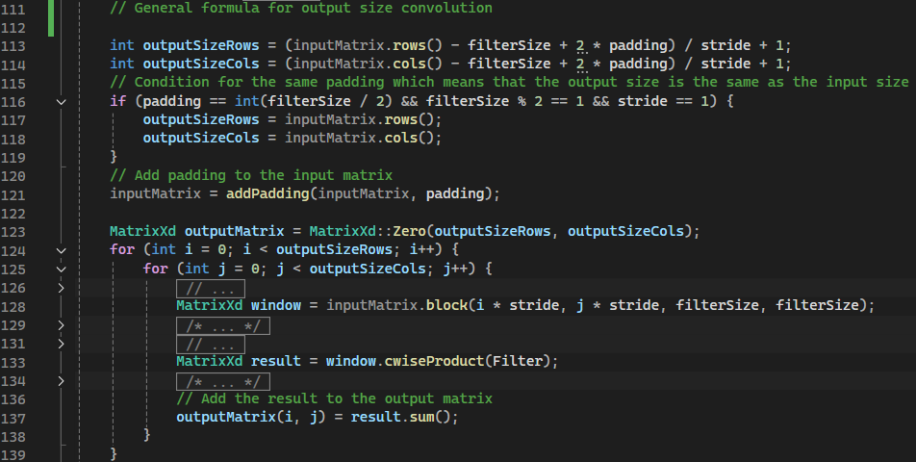

Code Listing .: Launch Main Body

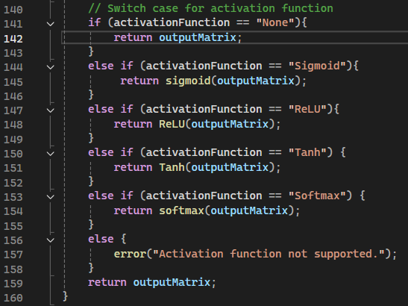

Code Listing .: Activation Function Switch Case

The comments in the listing should give a good description of the processes executed. Worth noting an assumption that for all operations filters are of the square size (i.e. number of rows equals the number of columns).

## Pooling

Two types of the pooling function were developed “max” and “average”. The attributes and description to them can be found in Code Listing 4.9 and Table 2. The implementation of the main “launch” function is presented in Code Listing 4.10 (error handling excluded).

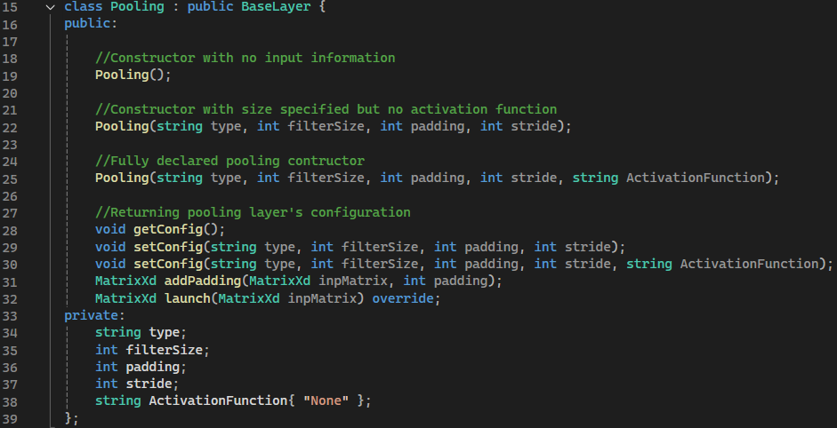

Code Listing .: Pooling Layer Class Attributes

|  |  |  |  |  |
| --- | --- | --- | --- | --- |
| **Name** | **Type** | **Return Type** | **Member Type** | **Purpose** |
| Pooling(Parameters) | Constructor | Class object instance | Public | Creates an object with the properties of the class |
| getConfig() | Getter | Void | Public | Prints the specification of the layer |
| setConfig() | Setter | Void | Public | Changes the specification of the layer |
| setFilter() | Setter | Void | Public | Changes the filter for the given layer |
| addPadding() | Function | MatrixXd | Public | Performs padding operation |
| launch() | Function | MatrixXd | Public | Main function that runs the layer |
| filterSize | Variable | Int | Private | Filter matrix size |
| padding | Variable | Int | Private | Padding size |
| stride | Variable | Int | Private | Stride size |
| type | Variable | String | Private | Defines the pooling operation |
| Activation Function | Variable | String | Private | Specified activation function |

Table : Class Attributes

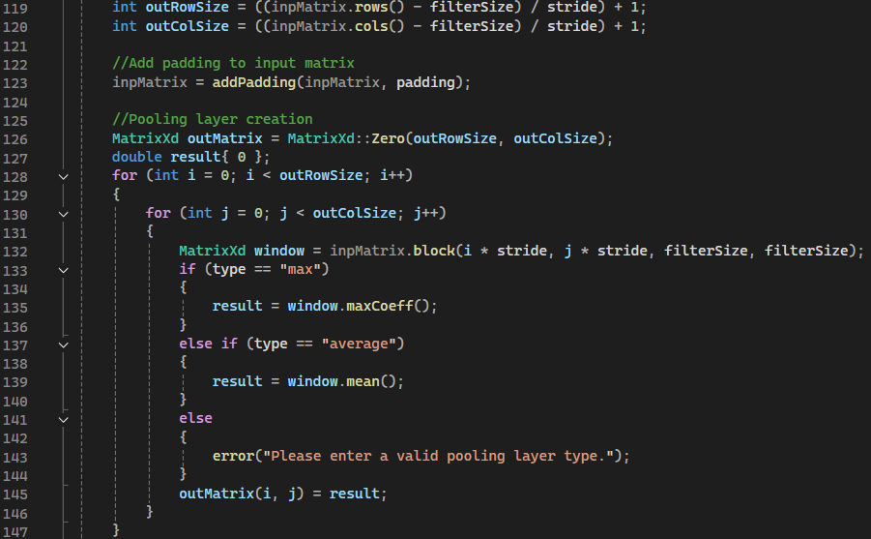

Code Listing .: Pooling launch implementation

Then the activation function is applied using switch case same as in Code Listing 4.8.

## Deconvolution

The Deconvolution layer consists of a header and a corresponding .cpp file, following the same structure as the other implemented layers. The list of class attributes is presented in Code Listing 4.11, with detailed descriptions provided in Table 3 and the “launch” function in Code Listing 4.12.

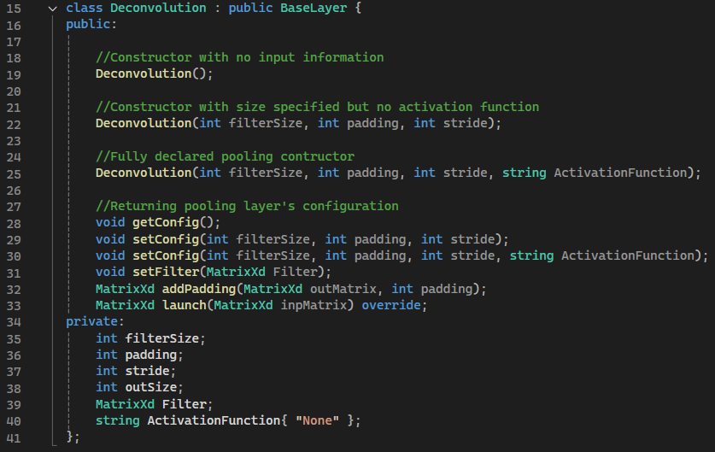

Code Listing .: Deconvolution Layer Class Attributes

|  |  |  |  |  |
| --- | --- | --- | --- | --- |
| **Name** | **Type** | **Return Type** | **Member Type** | **Purpose** |
| Deconvolution (Parameters) | Constructor | Class object instance | Public | Creates an object with the properties of the class |
| getConfig() | Getter | Void | Public | Prints the specification of the layer |
| setConfig() | Setter | Void | Public | Changes the specification of the layer |
| setFilter() | Setter | Void | Public | Changes the filter for the given layer |
| addPadding() | Function | MatrixXd | Public | Performs padding operation |
| launch() | Function | MatrixXd | Public | Main function that runs the layer |
| filterSize | Variable | Int | Private | Filter matrix size |
| padding | Variable | Int | Private | Padding size |
| stride | Variable | Int | Private | Stride size |
| outSize | Variable | Int | Private | Used to store the output size |
| type | Variable | String | Private | Defines the pooling operation |
| Activation Function | Variable | String | Private | Specified activation function |

Table : Class Attributes

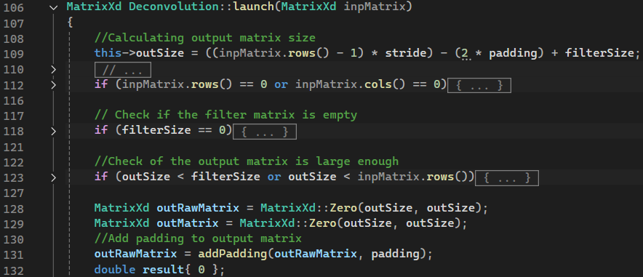 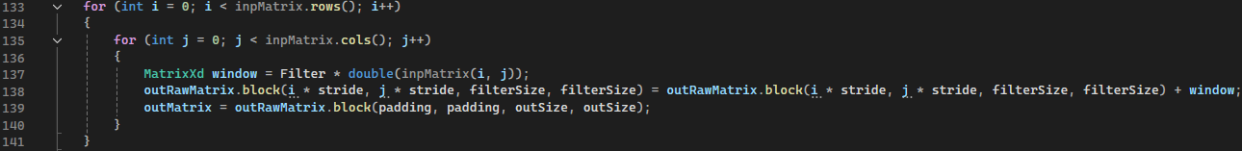

Code Listing .: Deconvolution launch implementation

Note that as the filter slides the input the window is being summed to the existed on the new output matrix. Same as before switch case activation function is applied after Code Listing 4.8

## Fully Connected

The last and the easiest layers to implement is fully connected layer. It’s attributes are shown and explained in Code Listing 4.13 and Table 4. The “launch” implementation is presented in Code Listing 4.14. As was mentioned above it was simplified down to multiplication of input and weight matrices. Finally the activation function is applied Code Listing 4.8.

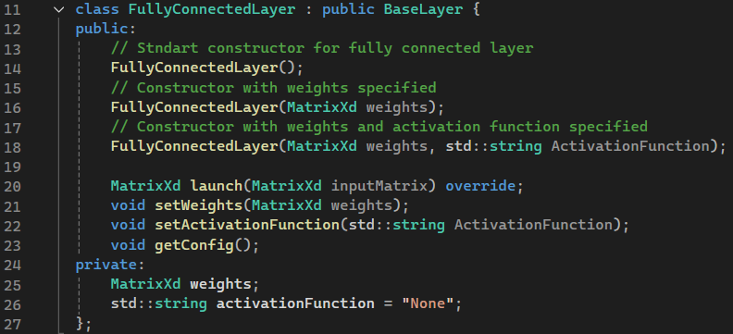

Code Listing .: Fully Connected Layer Class Attributes

|  |  |  |  |  |
| --- | --- | --- | --- | --- |
| **Name** | **Type** | **Return Type** | **Member Type** | **Purpose** |
| FullyConnectedLayer (Parameters) | Constructor | Class object instance | Public | Creates an object with the properties of the class |
| getConfig() | Getter | Void | Public | Prints the specification of the layer |
| setWeights() | Setter | Void | Public | Changes the weights to apply |
| setActivationFunciton() | Setter | Void | Public | Sets activation funciton |
| launch() | Function | MatrixXd | Public | Main function that runs the layer |
| Activation Function | Variable | String | Private | Specified activation function |
| Weights | Variable | MatrixXd | Private | Matrix of weights |

Table : Class Attributes

## Neural Network

The final and main goal of the project is going to be presented In this section. As before the attributes are provided and described in the Code Listing 4.14 and Table 5.

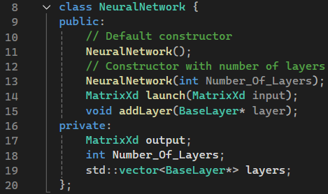

Code Listing .: Neural Network Class Attributes

|  |  |  |  |  |
| --- | --- | --- | --- | --- |
| **Name** | **Type** | **Return Type** | **Member Type** | **Purpose** |
| NeuralNetwork (Parameters) | Constructor | Class object instance | Public | Creates an object with the properties of the class |
| launch() | Function | MatrixXd | Public | Main function that runs the network |
| addLayer() | Function | void | Public | Add a layer pointer to the network vector |
| output | Variable | MatrixXd | Private | Used to store the output obtained through the layers operation and to be passed on to the next |
| Number_Of_layers | Variable | Int | Private | Stores the amount of layers in NN |
| layers | Variable | Vector<Baselayer*> | Private | Used to store layers as pointers |

Table : Class Attributes

The functionality of the launch function is presented in Code Listing 4.15. The process here is that for loop goes through the vector of layers and calls a function “launch” to the input and stores it in outputs. But “launch” method is defined differently for different layers which makes the operation specific to the layer to which the function is being applied.

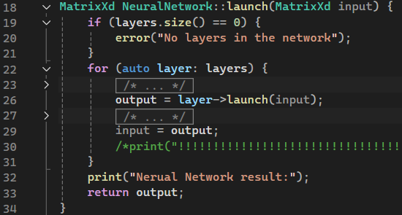

Code Listing .: Neural Network Launch Implementation

# Testing and results

This section is focused on testing each of the functionality implemented and shown in Section 4.

## Activation Functions

For the Activation Functions testing a simple matrix was created and then compared to the examples found on the internet. Further test listings provide the main code and the results of the application functions.

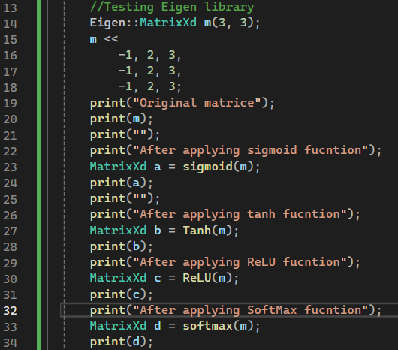

Test Listing .: Test inputs for Activation Function

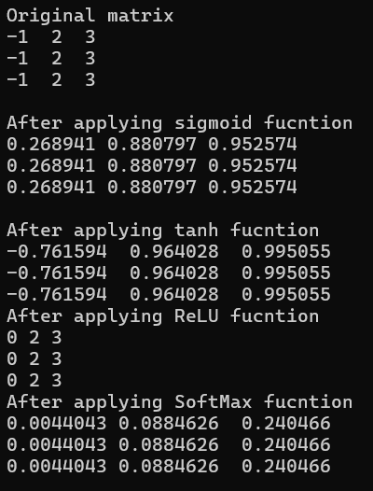

Test Listing .: Activation Function Testing Outputs

Functions Tanh, SoftMax and Sigmoid results were compared to the online examples and proved to be right. From the ReLU section of the report it is clearly seen that the ReLU function works as expected since negative values became 0 and others remained unchanged.

## Convolution Layer

Set of testing input and kernel is provided in Test Listing 5.3 and the results in 5.4 which were taken from the theory section Figure 3.1.

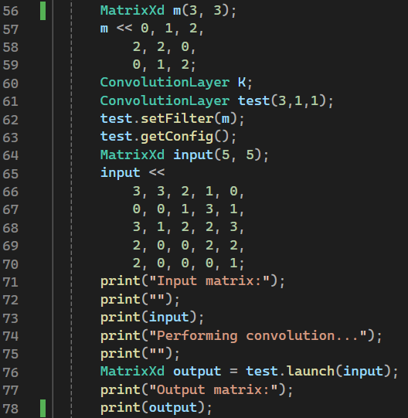

Test Listing .: Convolution Test Inputs

This code test the layer construction, it’s function “.getConfig()” which shows the settings of the layer and setFilter which sets the filter for the layer. This resulted in the following console output:

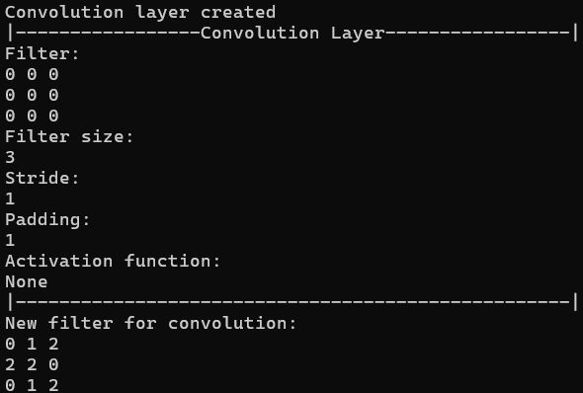 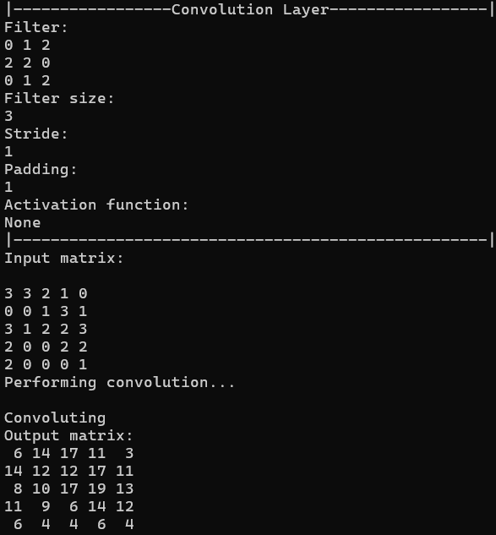

Test Listing .: Convolution Testing Output

This output proves that the layer works appropriately and passed the tests successfully. At all of the stages of convolution the error handling is included in the code and the example of the error handling is shown in Test Listings 5.5 - 5.6. Convolution construction value was changed to negative -3 and this resulted in the following output. The error occurrence suspends the process and exits the terminal.

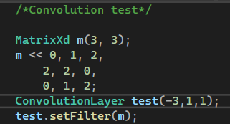

Test Listing .: Incorrect Value Passed



Test Listing .: Error Handling Testing Output

## Fully Connected

Having Fully Connected layer simplified to matrix multiplication it was tested using identity matrix with diagonal elements being 2’s which should result in an output of twice larger than the input. The tests are also including error handling test which is expected to give an error of wrong dimensions passed in.

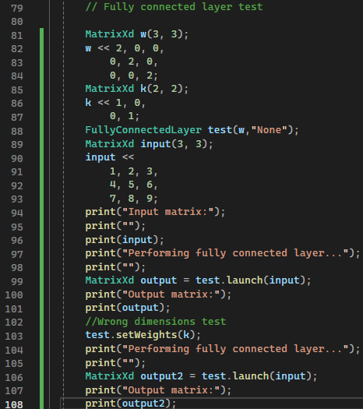

Test Listing .:Fully Connected Test Inputs

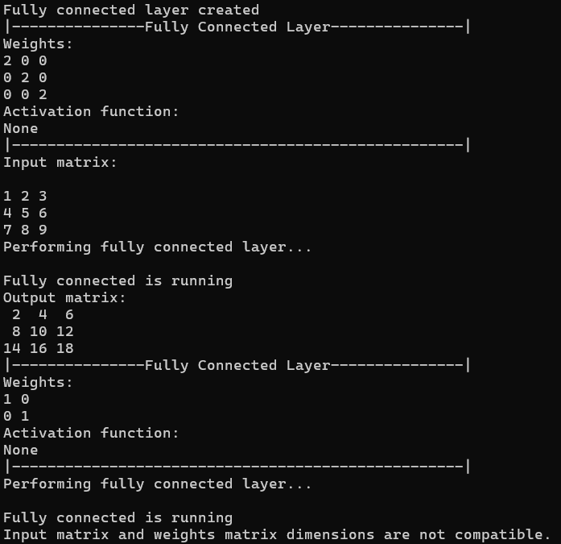

Test Listing .: Fully Connected Testing Output

The results confirmed that the layer operates correctly and that the error handling mechanisms function as intended.

## Deconvolution

Test input and the filter for the testing of the Deconvolution layer were taken from the online source [11] and shown in Figure 5.1. The code for testing and the results are provided In the Test Listings 5.9 – 5.10

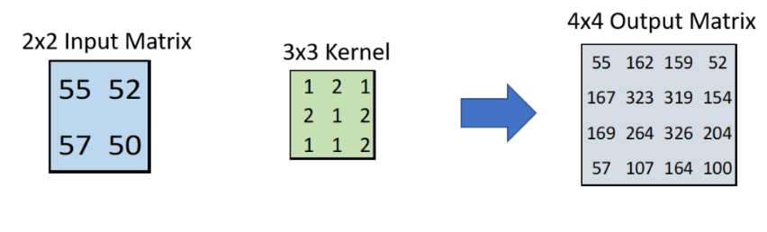

Figure .: Deconvolution Example Used For Testing

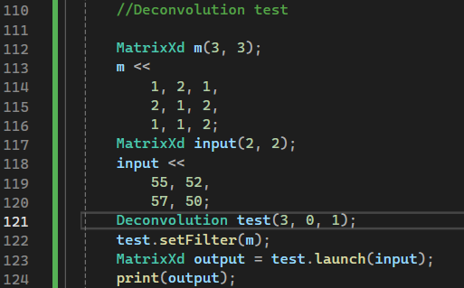

Test Listing .: Deconvolution Test Inputs

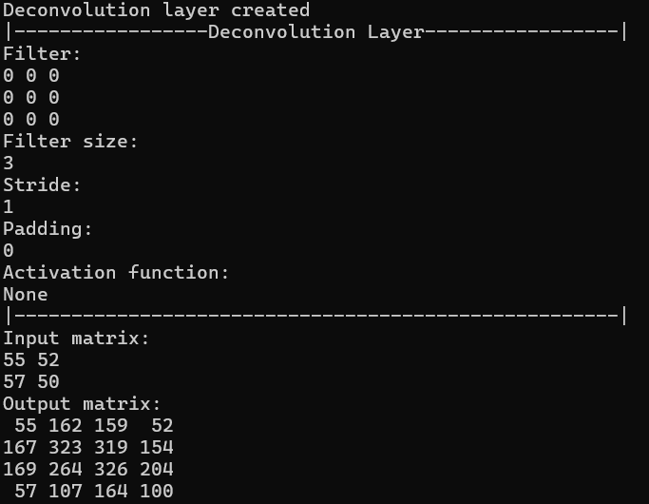

Test Listing .: Deconvolution Testing Output

A comparison of the outputs from Figure 5.1 and Test Listing 5.10 indicates that the test was successfully passed, confirming that the layer functions as intended.

## Pooling

The last layer to test was pooling test inputs were taken from the pooling layer theory section (see Figures 3.10 – 3.11). The results are presented in Test Listings 5.11 – 5.12.

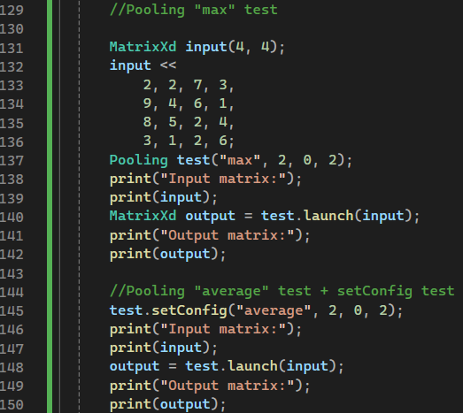

Test Listing .: Pooling Test Inputs

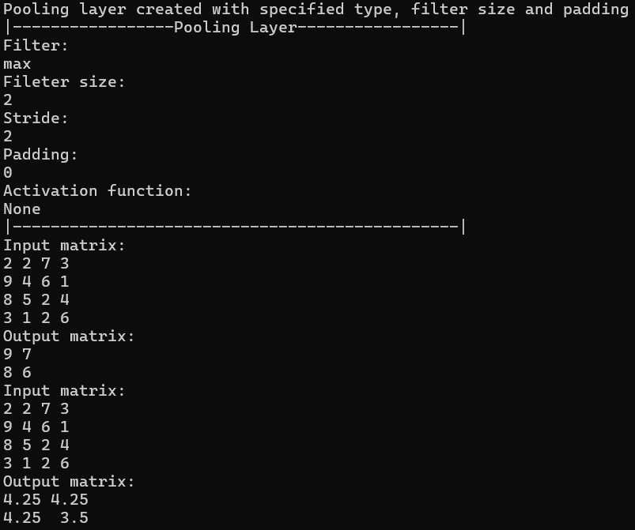

Test Listing .: Pooling Testing Output

The pooling layer was tested using input values derived from theoretical examples, and the results confirmed its correct functionality, with both tests successfully passed and values matched.

## Neural Network

Testing of the neural network required to create layers pointers and add them on to the neural network to be stored in a vector of Base Layer pointers and this is provided in Test Listings 5.13 – 5.14. In addition, a print function was added to be able to see the output matrix as it exits the layer and before being passed through the next one.

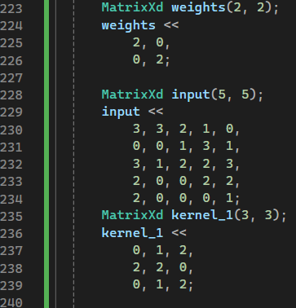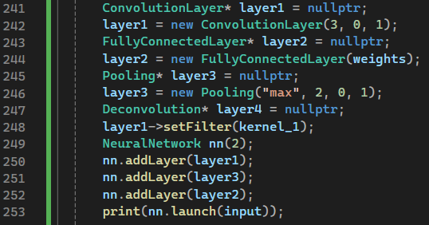

Test Listing .: Neural Network Test Input

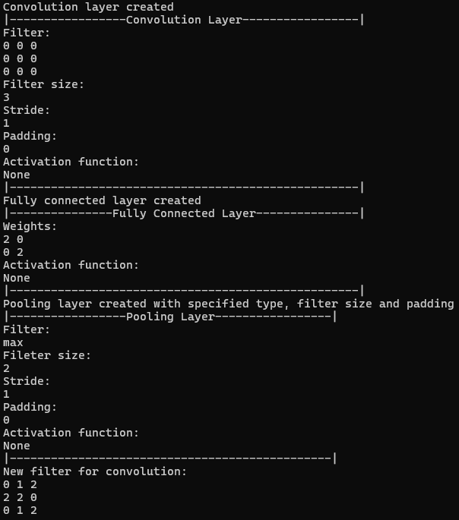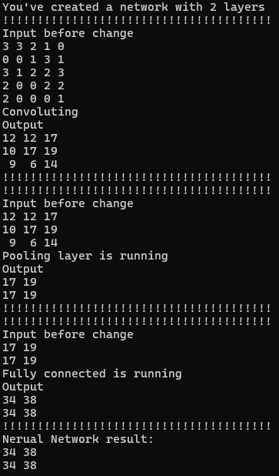

Test Listing .: Neural Network Testing Output

From the outputs it is concluded that the neural network works as expected and chains all the layers together with the ability to pass input from layer to layer. Moreover, worth noting that the output says that a neural network with 2 layers is created but 3 layers were added that is happening because in C++ vector type object is capable to self-allocate memory if it’s being increased and exceeds the size.

## Image Processing

An additional set of tests were conducted to check the functionality of the convolution layer for image processing. This is the part of the project where OpenCV external library was used. Examples of vertical, horizontal and outline edges obtaining using convolution are presented in this section with changing the kernel and image path in the code (see Test Listings 5.15 – 5.17). All the code needed for the process to run has all the appropriate comments, so a discussion of it is unnecessary.

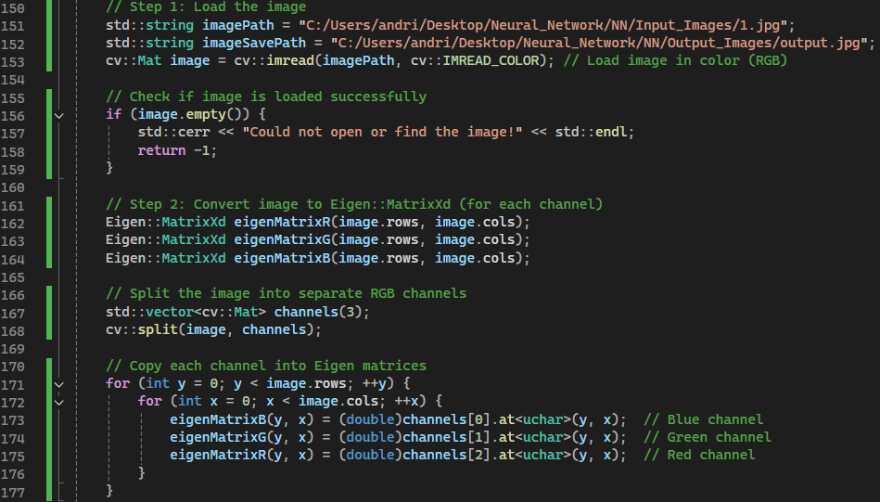

Test Listing .: Image Processing Step 1-2

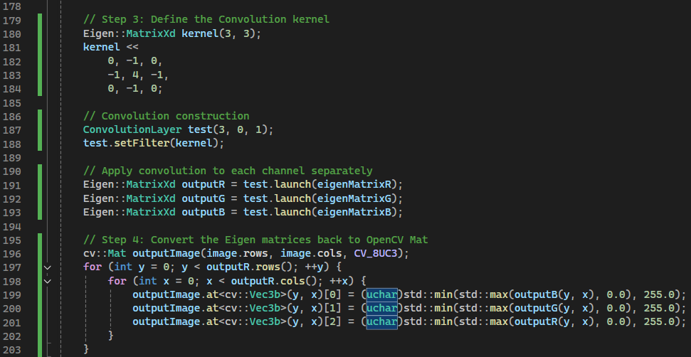

Test Listing .: Image Processing Step 3-4

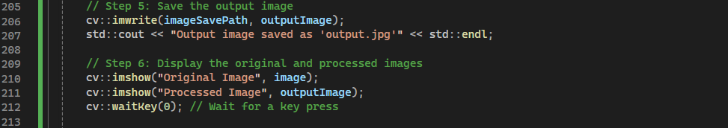

Test Listing .: Image Processing Step 5-6

The results obtained in Figures 5.2 – 5.7 demonstrate how powerful is filtering and can give a bigger understanding of how the map features are obtained and working in the neural network.

Figure .7: Processed with vertical filter



Figure .6: Original Image [12]



Figure .5: Processed with horizontal filter



Figure .4: Original Image [12]



Figure .3: Processed Image with outline filter



Figure .2: Original Image [12]

# Future work and improvement

The opportunities for the future works are huge. The layers developed could be extended to have a proper gradient calculation, inclusion of errors, backpropagation. After there the paths are almost endless. This CNN can be developed for voice recognition, image recognition, processing, classification. Less major improvements could be to extend the neural network class having the functions to print of the layers and delete them. Moreover, instead of using Eigen library a specific class Matrix could be written which can be more optimised, increasing the efficiency of the program.

This report was mostly completed by Andrii Kyrychok. As a result of this, the credit for major aspects of this report should be credited to Mr Kyrychok. In this version of the report, additions to background research and introduction were replaced with work from Ricardo Barrera, as this was his assigned sections. In addition, figures, reviewing and references were redone. Of the code, all except the use of Open CV was contributed to equally by Ricardo Barrera.

# Conclusion

This project successfully explored and implemented key components of convolutional neural networks (CNNs) by developing a modular library in C++ that simulates the operation of common neural network layers. Through detailed investigation and practical application, the project deepened understanding of the mathematical foundations and structural mechanisms of the CNNs, while also enhancing software development skills in areas such as linear algebra, error handling, and integration of external libraries.

The deliberate exclusion of backpropagation allowed the team to focus on the construction and chaining of layers — fully connected, convolution, pooling, and deconvolution, maintaining a manageable scope and ensuring the delivery of a functional, well-structured codebase. This simplification not only streamlined development but also reinforced core programming principles essential to the field of machine learning.

Overall, this project has provided valuable insights into both the theoretical and practical aspects of neural networks. It has laid a solid foundation for future work in AI systems, including more advanced topics like training models, optimizing performance, and integrating neural networks into real-world applications such as image recognition. It demonstrates the effectiveness of building systems from the ground up in understanding and applying fundamental concepts of modern computing.

# References

#UNDERSTANDING NEURAL NETWORKS

[1] – <https://www.flatworldsolutions.com/data-science/articles/7-applications-of-convolutional-neural-networks.php> - Uses of Neural Networks

[2] - <https://www.youtube.com/watch?v=zxagGtF9MeU&list=PLblh5JKOoLUIxGDQs4LFFD--41Vzf-ME1&index=>1 - StatQuest videos

[3] - <https://medium.com/analytics-vidhya/backpropagation-for-dummies-e069410fa585> - Backpropagation for Dummies

[4] - <https://www.researchgate.net/figure/Search-space-in-neural-network_fig3_313294143> - Image for backpropagation on weights

[5] - <https://www.geeksforgeeks.org/cnn-introduction-to-pooling-layer/> - CNN Description

[6] - <https://medium.com/@krushnakr9/deep-learning-convolution-neural-network-69fc0a588507> - CNN Application

[7] - <https://arxiv.org/pdf/1603.07285> - Guide to convolution arithmetic for deep learning

[8] - <https://builtin.com/machine-learning/fully-connected-layer> - Fully connected image

[9] - <https://www.youtube.com/watch?v=rpdclPvpaBM> - What are activation functions

[10] - <https://eigen.tuxfamily.org/dox/index.html> - Eigen

[11] -

<https://towardsdatascience.com/understand-transposed-convolutions-and-build-your-own-transposed-convolution-layer-from-scratch-4f5d97b2967/> - Deconvolution testing source

[12] - <https://www.vectorstock.com/> - Vector Images Source